Statistical Inference - Estimation

Statistical Inference:

Statistical inference is the branch of statistics which concerned with using probability concept to deal with certainty in decision making. The process of drawing inference about a population on the basis of information contained in a sample taken from the population is called Statistical Inference. Statistical inference has two parts-

- Estimation of Parameter
- Testing of Hypothesis

Estimation:

Estimation is a procedure by which we obtain an estimate of the true but unknown of a population parameter by using the sample observations 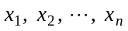.

Example: We can estimate the mean and variance of a population by computing the mean and the variance of a sample drawn from the population.

Estimator:

Any statistic (known function of observable random variables that is itself a random variable) whose values are used to estimate 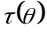, where 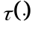 is some function of parameter , is defined to be an estimator of .

Estimate:

An estimate is a numerical value of the unknown parameter obtained by applying a rule or a formula.

Example: Let be a random sample of size from a population with mean , then 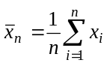 is an estimator of a mean and the expected value of 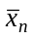 is an estimate of .

Show That All Estimators are Statistic but All Statistics are not Estimator.

We know that estimator by always a function of sample values by which we can estimate the parameter. Since the function of sample values are called statistic. So we can say that all estimators are statistic. But 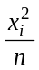 is a function of sample. So it is a statistic, we can not estimate any parameter. In this sense we can say that all estimators are statistic but all statistics are not estimator.

Distinguish Between Estimate and Estimator.
The main distinction between estimate and estimator are given below-
Estimate | Estimator
The numerical value of the estimator in a particular sample is called an estimate of the parameter. | Estimator is a statistic which is a function of sample observations and is used to estimate the value of a population parameter.
Estimate is depends on estimator. | Estimator is depends on samples.
The word estimate stands for a value of that function. | The word estimator stands for the function.
is an estimate of . | Estimator is a variable such that is an estimator of .

Properties of Estimators:
An estimator is said to be good estimator or best estimator if it has the following four properties-
- Unbiasedness
- Consistency
- Efficiency
- Sufficiency

- Unbiasedness:
An unbiased estimator is a sample statistic for which the expected value is equal to the parameter being estimated. An estimator of the parameter is called unbiased for if their exist the relation
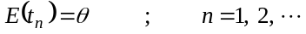
Example: If 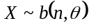 then 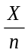 the observed proportion of success is an unbiased estimator of the parameter
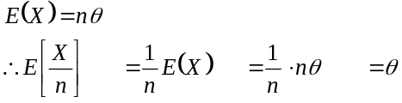
So, is an unbiased estimator of .

- Consistency:
Any statistic 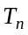 that converges in probability to a parameter is called a consistent estimator of that parameter .
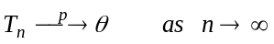
Example: Let 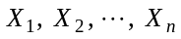 be a random sample form a population with finite mean 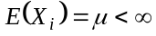, then by Khinchine’s weak law of large numbers , we have,
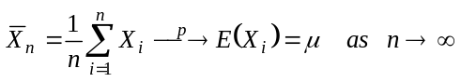
Hence sample mean 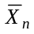 is always a consistent estimator of the population mean .

- Efficiency:
A criterion which is based on the variances of the sampling distribution of estimators is usually known as efficiency.

If there are two consistent estimators and 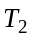 of a certain parameter , and if we have 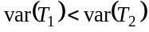 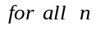 then is more efficient than for all sample sizes.

- Sufficiency:
An estimator is said to be sufficient for a parameter, if it contains all the information in the sample regarding the parameter. More precisely, if 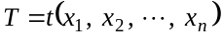 is an estimator of a parameter , based on a sample 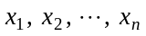 of size from the population with 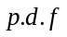 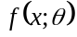 such that the conditional distribution of given is independent of , then is sufficient estimator for .

Example: Let be a random sample from a Bernoulli population with parameter , then for 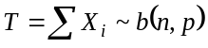 the conditional distribution of 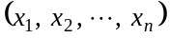 given is
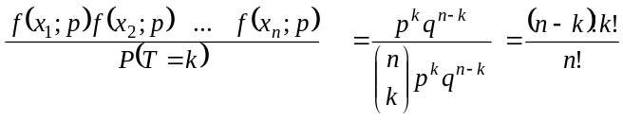
which is independent of . So is the sufficient estimator for .

Parameter Space:
The set of all admissible values of the parameters is called the parameter space or parametric space which is denoted by .

Problem:
Let 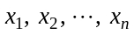 be a random sample with 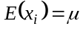 and 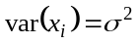 then show that 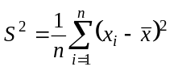 is a biased estimator for 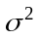 and 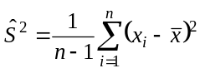 is an unbiased estimator for .

Solution:
We know that
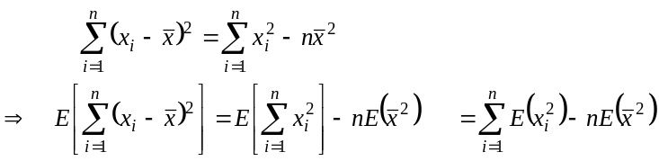
Again,
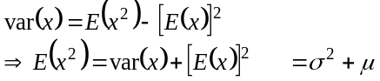
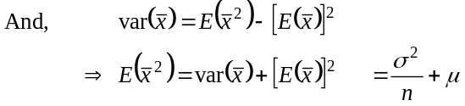
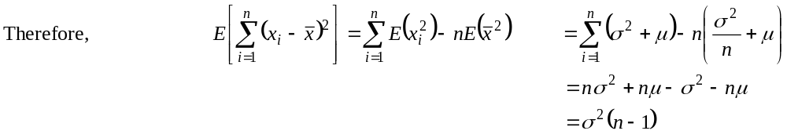
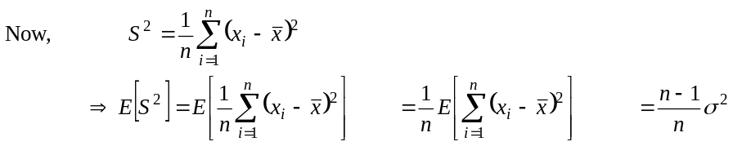
That is why 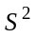 is a biased estimator of .
Again,
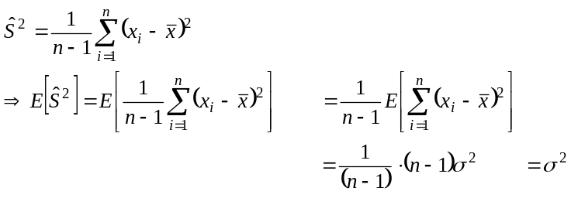
That is why 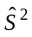 is an unbiased estimator of .

Problem:
Show that in random sampling from a normal population the sample mean is a consistent estimator for the population mean.
Solution:
Let be the random sample drawn from the normal population with mean and variance 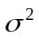. Then the sample mean is also normally distributed with mean and variance 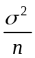. Thus,
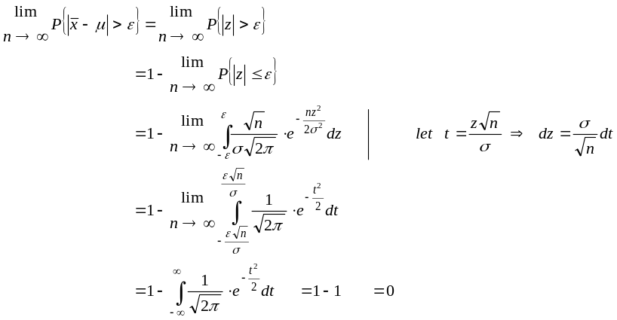
Hence the sample mean is a consistent estimator of the population mean .

Problem: If 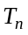 is an unbiased estimator of , variance of tends to zero as tends to infinity, then show that is consistent.
Solution:
We have to prove that is a consistent estimator of
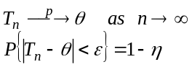
Applying Chebyshev’s inequality of the statistic we get,
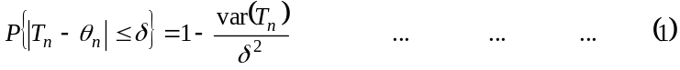
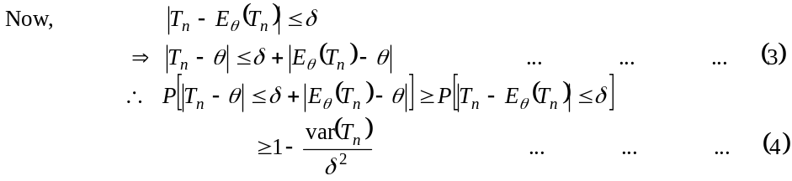
Since 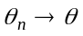 and 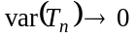 as , there exists an 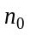 such that for all 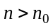
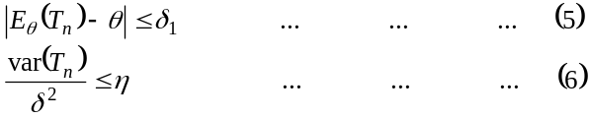
substituting from 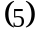 and 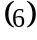 in 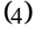, we get,
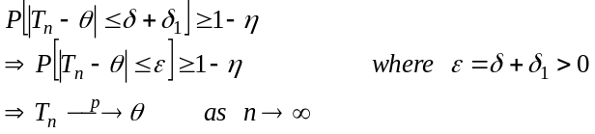
So, is a consistent estimator of .

Prove that 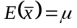
Let the population size 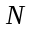 and the sample size is . Also let, is the sample mean and is the population. We
know that 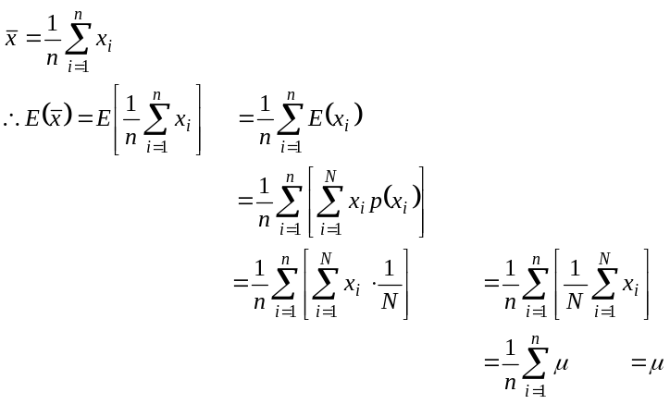
So, sample mean is an unbiased estimator of population mean .
Problem:
Let be a sample from Poisson distribution with parameter , then show that 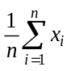 is an estimate of . Also 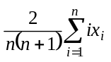 is an estimate of . So any is an estimate of .

Solution:

Since be a sample from Poisson distribution with parameter . So, we have, 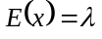
Now,
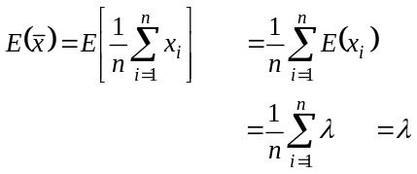
Again,
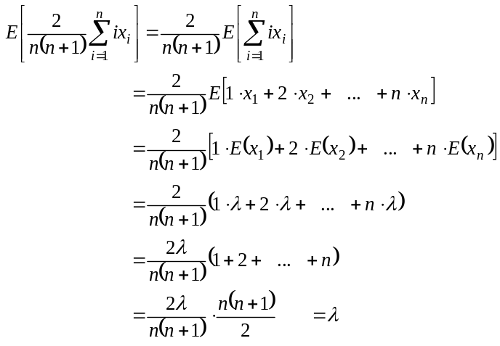
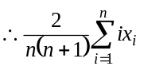 is an estimate of . Here we can see that any is an estimate of .

Problem:
Let be a random sample from 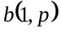, then show that 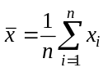 is an estimate of . Also show that some other estimates of are 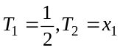 and 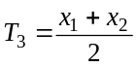.
Solution:
Since be a random from , then we have, 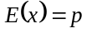
Now,
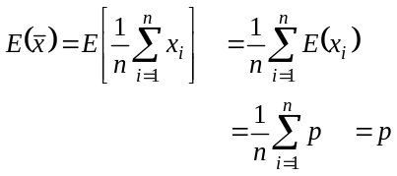
Again
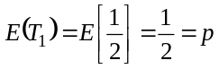
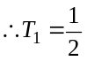 is an estimate of .
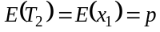
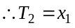 is an estimate of .
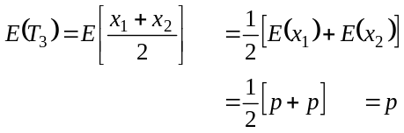
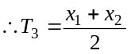 is an estimate of .

Problem:
Let be a random sample from 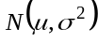, then show that the 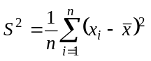 is a biased estimator of . Hence also find the amount of bias.

Solution:
We have,
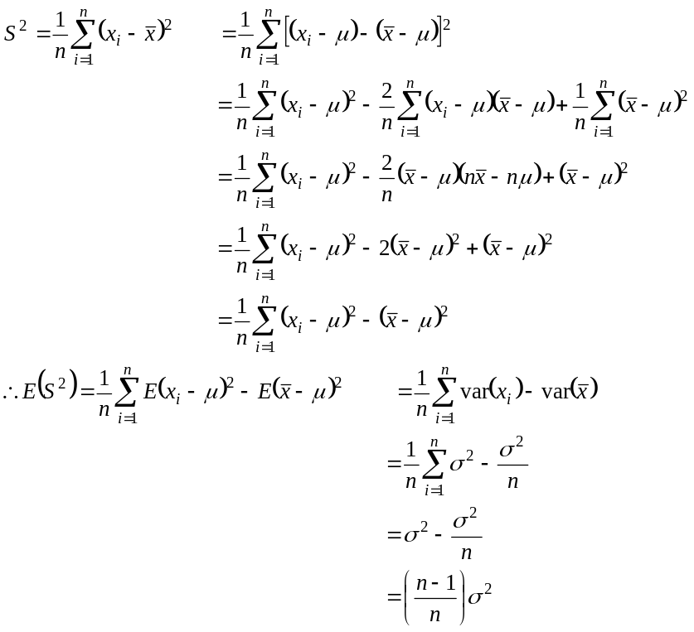
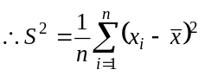 is the biased estimate of .

Making Unbiased:
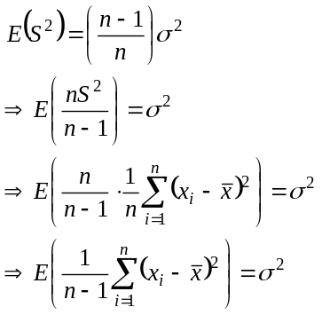
So, 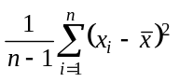 is an unbiased estimate of .
We know that,
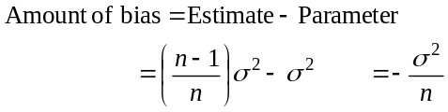
So, 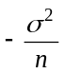 is the amount of the bias.

Problem:
If 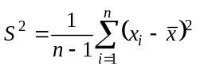 is an unbiased estimate of then show that 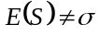 i.e. is not an unbiased estimate of , where are 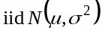.

Solution:
Since are then we know that 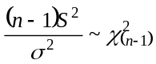
Therefore,
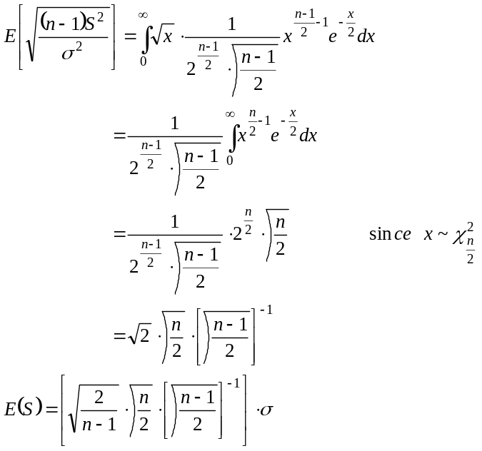
So, is not an unbiased estimate of .
random sample:
Show that unbiased estimates may not always exists.

Proof:
Consider a random variable with 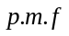 . Suppose that we wish to estimate 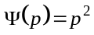. Then in order that be unbiased for 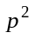, we must have,
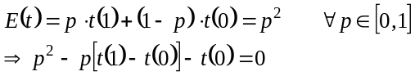
which is not possible because if a convergent power series 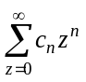; 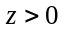 vanishes for all values of lying in a closed interval the coefficients 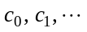 must be identically zero. So, unbiased estimate may not always exist.

Problem:
If be drawn from the population with
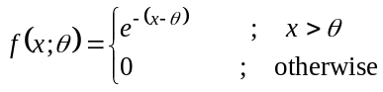
then show that 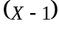 is an unbiased estimate of .

Solution:
We have,
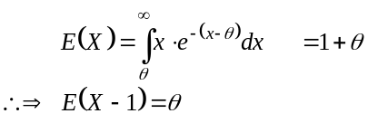
So, 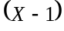 is an unbiased estimate of .

Problem:
If 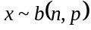 then show that 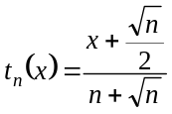 is a biased estimate of and also find out the amount of bias. Also show that 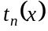 is asymptotically unbiased.

Solution:
We have, 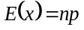
Now,
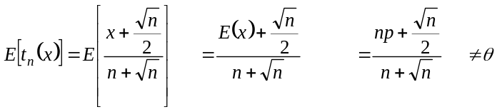
So, 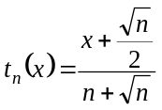 is a biased estimate of .
We know that,
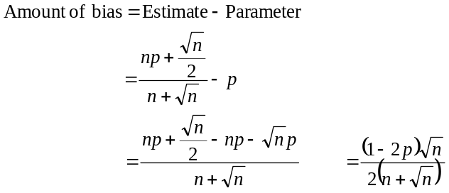

Problem:
Show that for 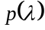, there is no exactly unbiased estimator of 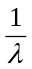.

Solution:

